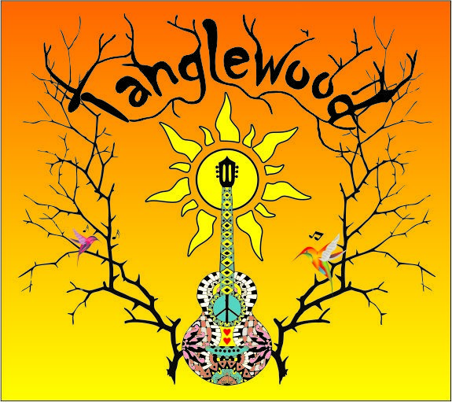
Tanglewood is……. a tangle of genre, spirit, and passion for heartfelt music Americana style with a mix of inspiration.
Ann Meadows, a singer, songwriter, guitarist, and percussionist whose musical range encompasses a true Americana mix of genre. Ann's musical creativity, has culminated her into a sensitive songstress. The personal depth of her stories and melodic interpretation, speak volumes of her years of experience as a seasoned singer songwriter and aid in her interpretation of many long time favorites.
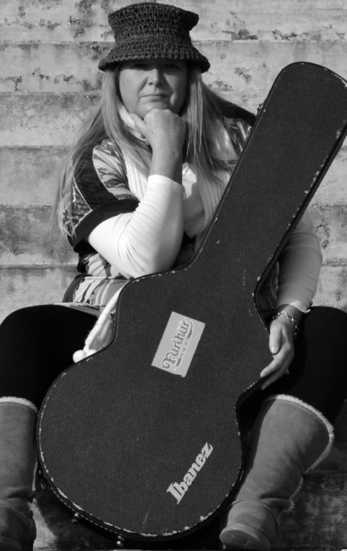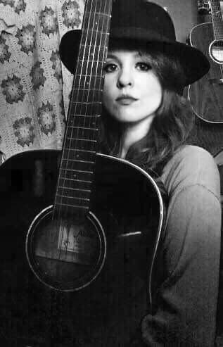
Laura Davis has a great love for music of all kinds. This self taught guitarist, session musician, and vocalist has a blossoming resume. Laura performs studio sessions for many top professional artists in our area as well as her live projects with various performing artists. Her ability on the guitar almost brings to mind, the term “photographic memory”, but her spin offers such a fresh approach of blistering leads that even old time favorites all seem new.
Tanglewood offers a unique approach to old blues, rock, folk and originals by blending genres into a revival of soulful freshly inspired Americana music. Just two girls and their guitars passionately doing what they have been called to do.
Tanglewood , Americana music as it’s best, available for bookings. For more information and rates, please contact Ann at 252-673-6316 or by email at anniesguitar@hotmail.

